Please Post 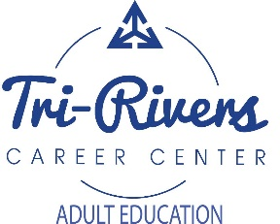 Please Post

TRI-RIVERS JVS DISTRICT
POSITION VACANCY

POSTING DATE: | December 10, 2018
POSITION: | Part-Time Adult Education Skilled Trades Instructor(s)
REPORTS TO: | Adult Education Director
MINIMUM REQUIREMENTS: | - High School Diploma.  - Minimum of three (3) years of field experience in subject area. (Excellent position for recently retired Skills Trades Technician.)  - Positions are available for a number of skilled trades instructors. Trades including Robotics: FANUC Yaskawa and/or Universal Robots, electrical and mechanical controls, hydraulics, programmable logic controllers (PLCs; Allen Bradley and Mitsubishi).  - Classroom experience beneficial but not required. Positions are available for both lead instructors and assistant instructors.  - Eligible for Ohio Department of Education Adult Education Teaching Certificate.  - BCI/FBI background check required prior to employment.  - Basic computer skills.
QUALIFICATIONS: | Major Responsibilities Include:  Instructs class following course objectives and standards set forth by the Ohio Department of Education and Tri-Rivers Center for Adult Education.  Displays competence in subject matter.  Assists with development of course materials including, but not limited to presentations, quizzes, handouts, tests, and hands on labs.  Encourages student involvement in learning, while promoting a positive student self-concept.  Attends related in-service and staff meetings.
WORK YEAR: | Part-time contract.
SALARY: | Per Board Approved Part-Time Salary Scale.
STARTING DATE: | Ongoing
APPLICATION PROCEDURE: | Complete application and send resume, copies of any certifications and licensures, three references and cover letter detailing skills and qualifications for the position. Application forms are available by calling 740-389-4681, ext. 7441.
SUBMIT APPLICATION MATERIALS TO: | Submit an employee application (available online at http://tririvers.com or in the Superintendent’s office) and related materials to:  Mrs. Debbie Curtis, Executive Assistant  Tri-Rivers Career Center  2222 Marion Mount Gilead Road  Marion, OH 43302

Equal Opportunity: In accordance with Title VI, Title IX and Section 504 of the Rehabilitation Act of 1973, The Tri-Rivers Career Center Board of Education has a policy prohibiting discrimination against any person on the basis of sex, race, religion, disability, age or national origin.

