Senior Class
Guide
2020-2021

Student Services Organization
Mrs. Dunn:
sdunn@tririvers.com
Elgin, North Union, and Other schools not listed
Mrs. Large:
klarge@tririvers.com
Marion Harding, Pleasant, and Ridgedale
Mrs. Lauthers:
alauthers@tririvers.com
Cardington, Highland, Mount Gilead, and River Valley

For updates and important information:
-Join your school counselor’s google classroom
-Check your school email for school specific updates and info

GOAL #1-GRADUATE!
- Credit Concerns
We will be working to meet with each student to take care of any other necessary paperwork needed. Please complete/sign all necessary forms and return to your counselor ASAP by October 9, 2020. Remember there are deadlines to complete your courses. When in doubt ask your counselor!

- Attendance
Be HERE 98% or more of the time.

- Graduation Pathways
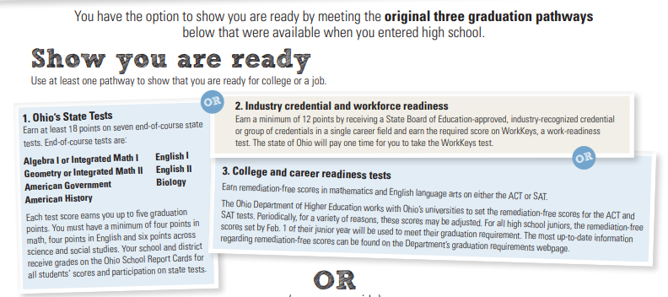

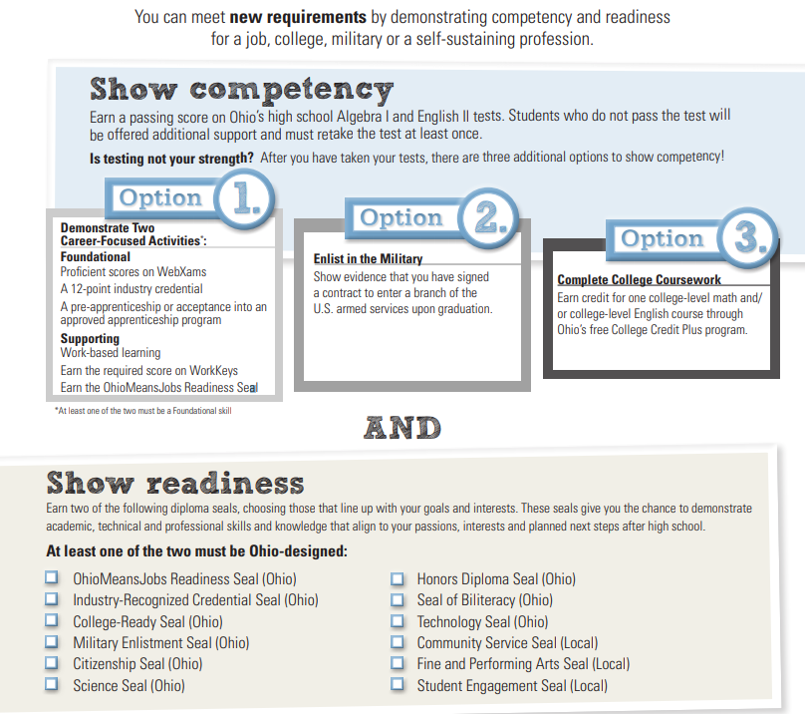
The Next Step…
College
Visitation Days- 1 per semester (Must be completed BY MAY1) 2 total for the year.
-Contact your counselor to start the paperwork at least 7 school days in advance!
-Completed paperwork must be returned to Student Services and approved 3 days in advance
-Must be passing all classes with a C or higher
-Not more than 3 unexcused absences in the quarter the visit is requested
-Must have parent consent (even if you are 18 or older)

ACT (Placement Test)
The ACT is an all multiple-choice test consisting of 215 questions. The ACT assessment tests knowledge in four subject areas: English, Reading, Math, and Science Reasoning. There is an optional Writing test as well. The questions on the ACT are directly related to the materials students have learned in high school.

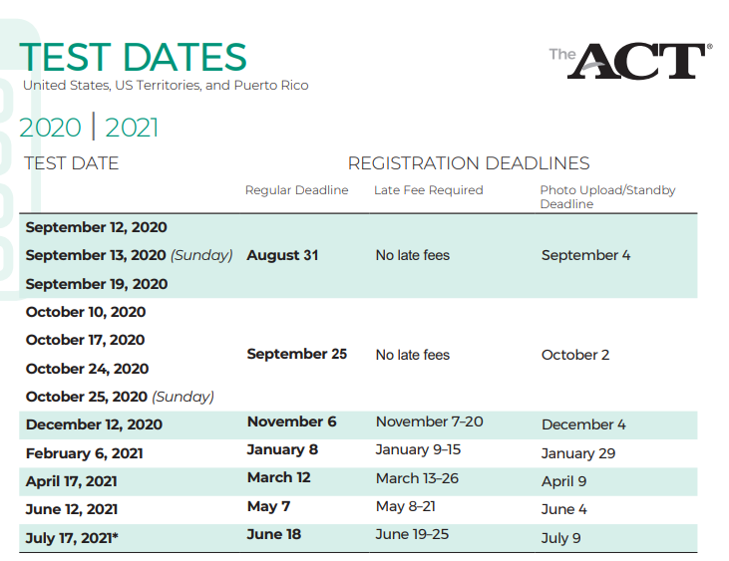

Test Fees:
 | Fee | Details
The ACT (no writing) | $55.00 | Includes reports for you, your high school, and up to four colleges (if codes are provided when you register).
The ACT with writing | $70.00 | Includes reports for you, your high school, and up to four colleges (if codes are provided when you register). More about the ACT with writing
Test option change | $15.00 | The writing test fee is refundable on written request if you are absent on test day or switch to ACT (no writing) before testing begins.
Register online at www.actstudent.org
See your counselor in advance for registration information. Students that qualify for free and reduce lunch may get 1 fee waiver during their senior year.

*All Marion City Students will receive 1 fee waiver for the test from Marion City. See Mrs Large for the waiver.
Who needs to take the ACT?

ALWAYS check with the college you plan to attend if you are unsure whether you need to take the ACT.
-Students pursuing a 4 year Bachelor’s degree
-Student pursuing 2 year associates degree in certain fields
-Student wishing to apply for scholarships
-Many colleges use ACT scores to help in placement of college courses

What if I am planning on attending a Trade school or Associate Degree?
-ACT is normally required but check with the school to be sure
-If applying for scholarships, it is very important for you to take the ACT
-Often these schools require the ACCUPLACER or COMPASS test
How can you prepare?

https://academy.act.org/

https://www.march2success.com/

https://jobseeker.ohiomeansjobs.monster.com/
Scholarships

-Register online for Scholarship Web searches ASAP (fastweb.com)
-Scholarship updates will be available beginning in January in Student Service Office.
-Check regularly your home school website and your home school counselor for school specific scholarships
-Get active in your CTSO and other organizations…Volunteer
-Sign up for TRCC class of 2021 Scholarships on Remind for all scholarships code 8agadgf

FAFSA
-Oct 1, 2020 you can file for the 2021-2022 school year! FILE Early, there are a few federal student aid programs that have limited funds, so be sure to apply as soon as you can once the FAFSA is available for the year you’ll be attending school.
-You will use the prior year’s information to complete the FAFSA
-Create a FSA ID, which consists of a user-created username and password, replaced the PIN effective May, 2015. It allows users to electronically access personal information on Federal Student Aid Web sites as well as electronically sign a FAFSA. https://fafsa.ed.gov/FAFSA/app/fafsa
- Complete the FAFSA https://fafsa.ed.gov/index.htm

Military
-Visitation Days- 1 per semester (in place of a college day; must be completed BY MAY1)
-Contact your counselor to start the paperwork at least 7 school days in advance!
-Completed paperwork must be returned to Student Services and approved 3 days in advance
-Must be passing all classes with a C or higher
-Not more than 3 unexcused absences in the quarter the visit is requested
-Must have parent consent (even if you are 18 or older)
- Military personal must sign form that your attended

What’s Your E? Enrolled.Enlisted.Employed.
Established to recognize seniors who have been accepted to college, technical school, inducted or sworn into a branch of the military, or have been approved for early job placement or paid internship.
Be proud of your next step! Check out the wall across from the Main office to see last year’s seniors posters!
Must present form along with written documentation of acceptance to Mrs. Muprhy in the main office.

Passport
This is a snapshot of the training and credentials you have completed during high school. This is a great way to show off your skills to an employer! Keep track of any awards, certificates, news articles and community service activities you have earned during your high school career! You can add these to your passport after you receive it.

Senior Recognition Night
Senior Recognition night will take place in May this year. There will be more details to follow!

Senior Checklist
*In no particular order*
___ Make and keep a folder for this material as well as any other college related information
___ Share this information with your parents!
___ Check your homeschool websites often for important dates and information
___ Update your resumes
___ Ask at least 2 people to write letters of recommendation for you (give them plenty of time to do this!) *teachers, coaches, employer, counselor, family friend…
___ Make some decisions about you future -2 year college, 4 year college, military, work?
___ Consider 2 or 3 colleges to visit and apply (1 reach school, 1 school you love, 1 school as a backup)
___ Consider military options- make contact/commitment if interested
___ Take the ACT at least once-check with your college about needing the writing section
___ Look for a list of scholarships on TRCC website as well as home school website
___ Look at career/scholarships/financial aid information from various websites
**** NEVER pay for any scholarship or financial aid services..these are FREE
___ Request your FSA ID
___ Fill out the FAFSA. NEW date of OCT 1 for the 2021-2022 school year
___ Apply to colleges (set a deadline of Dec 1 to have your applications in to ensure you get the most scholarship money)
___ Make deposit to college by May 1
___ After you make you deposit: check for housing information, testing requirements, scheduling, orientation, and coach contacts
___ If college/ military are not in your plans for next year, make employment plans!

